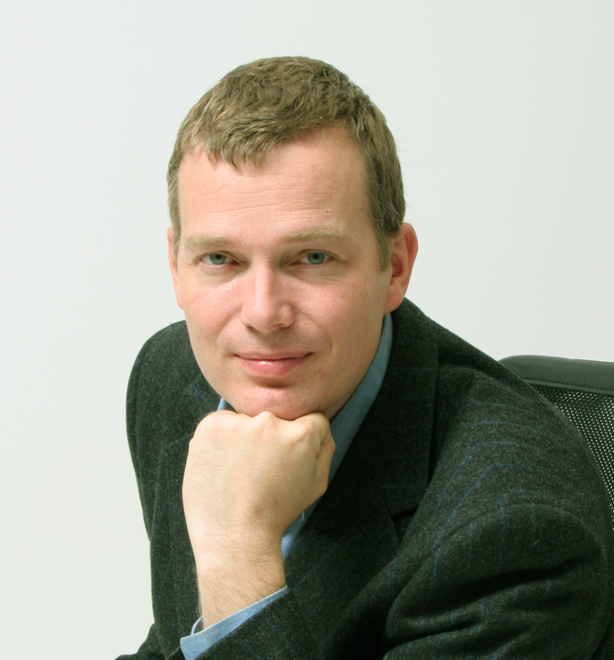 |  |  | CV curriculum vitae
 |  |  | Egil Möller
 |  |  | Free Software Consultant
 |  |  | egil.moller@freecode.no
 |  |  | +47 – 911 70 593
PROFILE |  | Highly competent free software developer and system administrator. Egil is the man behind the project Grimoire – an advanced system administration tool for large-scale and distributed systems. Excellent learning aptitude. Fluent English and Swedish.
SKILLS |  | Computer Science Philosophies and Conceptual Modelling  Programming paradigms: Object-Oriented Programming (OOP), Logic programming, Functional programming, Constraint programming  Project/design modelling: Waterfall and Iterative development processes with Unified Modelling Language (UML), Entity Relation Modelling.  Formal Languages  Main programming languages: Python, C, Scheme, PHP  Minor programming languages: javaScript, x86 assembler, Prolog, Common Lisp, Pascal, ML, Basic  Scripting languages: Bash, m4  Document and styling languages: LaTeX, XML, XHTML, Postscript, XSLT, CSS  Development Tools  Version control: Arch/Tla, SVN, CVS  Editing environments: Emacs, VC++  Debuggers: gdb, the python debugger, VC++  Software Libraries and APIs  Operating systems: Linux (various distributions), OpenBSD, Solaris and Win32  Databases: PostgreSQL, MySQL, Oracle, Cybase  User interface and graphics: Gtk+, Glade/libglade, SDL, direct Linux FB programming  Encryption: OpenSSL, M2Crypto, GPGME  Networking: TCP/IP using UNIX sockets, XML-RPC, SOAP, SUN RPC  Graphics Editing Tools  Raster based: GIMP (Similar to PhotoShop)  Vector based: Xfig, Inkscape (Similar toIllustrator), Autotrace, FontForge  System Administration    Operating systems: Debian, Ubuntu, RedHat, Mandriva, Windows 2k, Novell Netware  Network servers: Samba, Postfix, Courier, Cyrus, Apache  Databases: OpenLDAP, PostgreSQL  Certification  - IT Infrastructure Library (ITIL) foundation.
WORK EXPERIENCE |  | FreeCode AS, January 2007 -  Location: Norway  Title: Free Software Consultant  uAnywhere, 2006-06-09 - 2006-09-09  Location: Australia  Title: Linux programmer/System developer  Languages used: Python, PHP, C, Bash  Tools used:OpenLDAP, Samba, MySQL, PostgreSQL, OpenWRT, Oscilloscope, Soldering iron  AB TakeIT, 2003-01 - 2005-07  Location:Sweden  Title: Linux programmer/System developer  Languages used:Python, C. For minor projects: Prolog, Scheme, Bash, Postscript, LaTeX, XSLT  Tools used/Libraries used:OpenLDAP, PostgreSQL, OpenSSL, Arch/TLA  Graphics tools used:GIMP (Similar to PhotoShop), Xfig, Inkscape (Similar toIllustrator) , Autotrace  Published Free Software:Grimoire  IDA, Linköping University, 2002-06 - 2002-12  The WITAS project  Location: Sweden  Title: Amanuens (Technician: Programming, Windows and Linux administration)  Languages used: LISP, C  Tools used/Libraries used: Arch/TLA, CVS, SDL  MandrakeSoft SA, 2001-06 – 2002-06  Location: France  Title: Linux programmer  Languages used:C, Python, Bash  Tools used/Libraries used: CVS, Gtk+, direct Linux FB programming  Graphics tools used: GIMP  Published Free Software:Aurora (The first graphical boot-splash for Linux)  HERN Labs AB (Now Opera Software AB), 2000-08 - 2001-06  Location: Sweden  Title: Programmer (Linux and Windows programming)  Languages used: C++  Tools used/Libraries used: In house game-libraries, CVS, VC++  Nyströmska Skolan, 1998-06 - 1998-09  Location: Sweden  Title: System co-administrator  Tools used:Novell Netware  Söderköpings Tekniska Dator Support, 1997  Location: Sweden  Title: Software installer (on site hardware set-up)
EDUCATION |  | 2002 (Spring) 10 uni points: French at Linköping University, Sweden  1998-2000,  2001(Autumn),  2002 95 uni points: MSc of Computer Sience at Linköping University, Sweden  1995-1998 Nature Sience (NVN) at Nyströmska gymnasium Söderköping, Sweden  1993-1995 Ramunderskolan, Söderköping, Sweden  1991-1993 Hammarspången, Söderköping (Waldorfschool), Sweden  1986-1991 Kristofferskolan, Stockholm (Waldorfschool), Sweden
OTHER ENGAGEMENTS |  | Volunteer work experience  2005 Woodford Folk Festival, Australia Check in, Bar-cashier  2005 Exodus, Australia Car park, Staging  2005 Arvika Music Festival, Sweden Cashier and group-leader for the volunteer check-in  2004 Linköping Folk Music Festival, Sweden Cashier
LANGUAGES |  | Fluent in Swedish and English. Good skills in French.
SUMMARY |  | Egil is the resource to depend on when difficult technical tasks need to be solved. With insight into core technology in a wide variety of free software systems and ability to assess yet unknown situations quickly, he is able to create great value for our customers.

